**Lab # 10**

**Aim:**

Verification of state tables of J-K flip-flop and T flip-flop using AND and NOR gates.

**Apparatus:**

IC 7402 (NOR Gate), IC 7411 (AND Gate).

**Theory:**

In case of sequential circuits the effect of all previous inputs on the outputs is represented by a state of the circuit. Thus, the output of the circuit at any time depends upon its current state and the input. These also determine the next state of the circuit. The relationship that exists among the inputs, outputs, present and next states can be specified by either the state table or the state diagram. The state table representation of a sequential circuit consists of three sections labelled present state, next state and output. The present state designates the state of flip-flops before the occurrence of a clock pulse. The next state shows the states of flip-flops after the clock pulse, and the output section lists the value of the output variables during the present state.

**Flip-Flop:**

The basic 1-bit digital memory circuit is known as flip-flop. It can store either 0 or 1. Flip-flops are classifieds according to the number of inputs.

**Latch vs Flip-Flop:**

The circuit is similar to latch except enable signal is replaced by clock pulse. **J-K Flip-Flop**:

**Logic Diagram: Truth Table:**

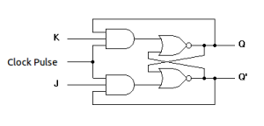

| **CP J K Q(t+1)**  0 x x Qt (NC)  1 0 0 Qt (NC)  1 0 1 0 (Reset) 1 1 0 1 (Set)  1 1 1 Qt**'** (Toggle) |
| --- |

**T Flip-Flop:**

T flip-flop is known as toggle flip-flop. The T flip-flop is modification of the J-K flip-flop. Both the J-K inputs of the J-K flip-flop are held at logic 1 and the clock signal continuous to change.

**Logic Diagram: Truth Table:**

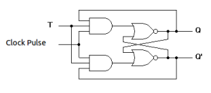

**Procedure:**

**1.** Connections are made as per circuit diagram. **2.** Verify truth- tables for various combinations of input.

**Precaution:**

**1.** All the ICs should be checked before using the apparatus. **2.** All LEDs should be checked.

**3.** All connections should be tight.

**4.** Always connect GROUND first and then VCC. **5.** The circuit should be off before changing the connections.

| **CP T Q(t+1)**  0 x Qt (NC)  1 0 Qt (NC)  1 1 Qt**'** (Toggle) |
| --- |

**6.** After completing the experiment switch off the supply to apparatus.

**Pre Lab Questions:**

**1) Differentiate between combinational and sequential circuits.**

Ans. A circuit whose output is dependent only on the inputs at that instant is called combinational circuit. And a circuit whose output is dependent on present and past history of the inputs is called sequential circuit.

**2) What is a latch?**

Ans. Storage elements that operate with signal levels are referred to as latches.

**3) What is a flip-flop?**

Ans. Storage elements controlled by clock transitions are called flip-flops.